INTEGRATED SYSTEM FOR FABRIC REAL-TIME GRADATION & PACKING

Touch Screen Monitor shall display Quality Code, Length in Meters, defects, width, GSM, weight of roll, Points/ 100 SQ. meter and fabric grade

Digital Length Counter

Acquire batch number from machine, software will get data from ERP @ background and display details in monitor

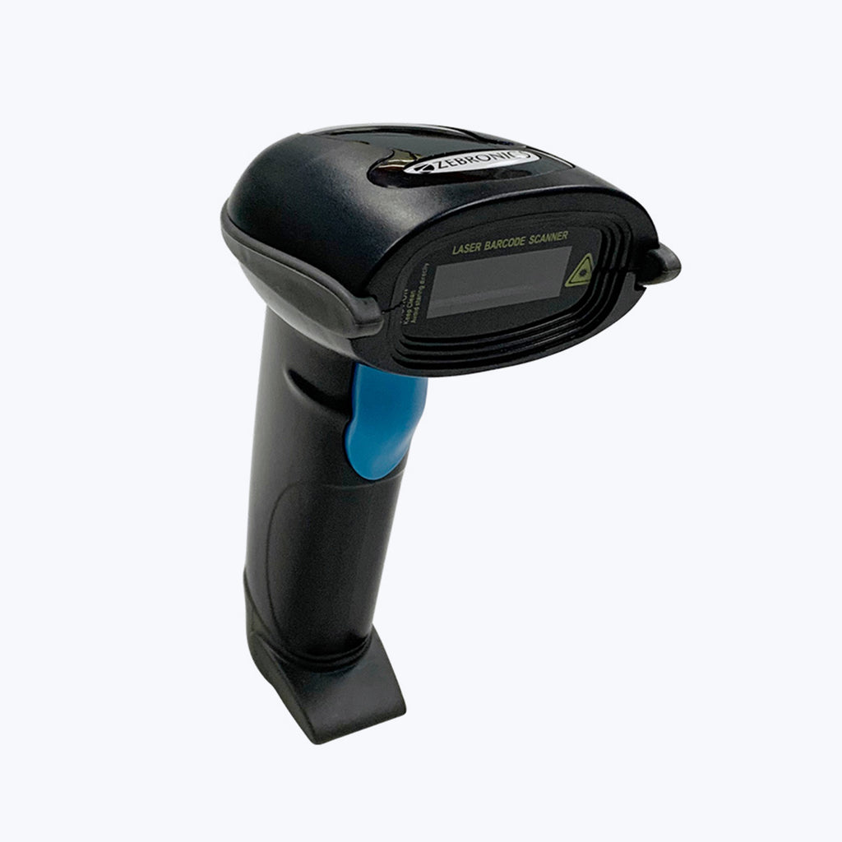

Industrial Mini PC connects to monitor, QR Scanner, company ERP network, Digital Length Counter, Auto Width Counter, GSM Scale, Barcode printer, Roll Weighing Scale to process the real-time data.

Digital Width

Counter

Digital Length measurement would display and real-time length and width measurement would display real-time width of the running fabric

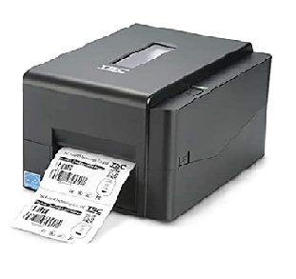

GSM cutting measured during inspection would be added towards roll number.

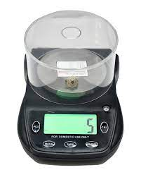

Rolls created would be automatically graded, Roll Number auto generated, barcode printed and sent for packing

Mini PC with RS-232 Port

Roll Weighing Scale

Fidas software

Batch/job card details would be displayed on touchscreen monitor after approval for inspection. Defects are manually punched by fabric checker. Other details such real-time GSM, WIDTH, Roll Weight is compared with fabric specification and if roll passes all given criteria, roll be graded as pass roll.

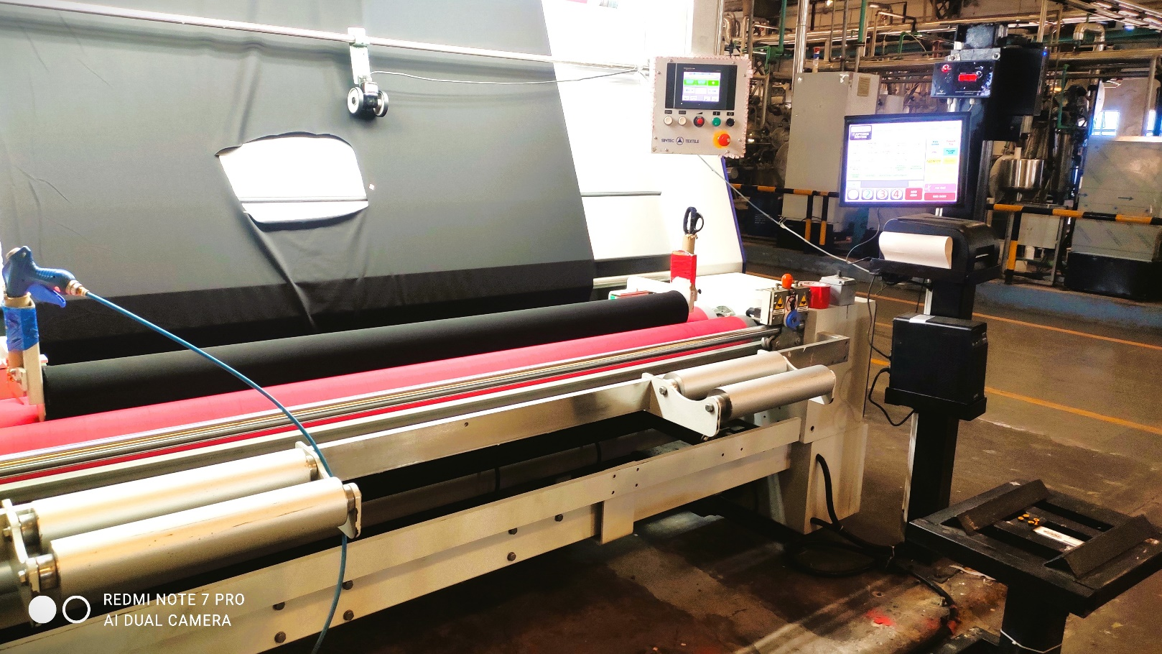

On-table GSM Scale

GSM scale is connected to FIDAS software and using Rs-232 port. Weighed GSM is compared to specified GSM and alert is provided is GSM is beyond tolerance.

Fabric Width Measurement System

Auto-Width measurement system displays real-time width of fabric during inspection and provides alert in case of less width ..

Fabric Length Measurement System

Dual Wheel Encoder is connected to Electronic Length Measurement Counter and counter in turn connected to FIDAS Software vis RS-232 to display real-time length of fabric

Movable roll weighing scale displays actual roll weight on completion of inspection to FIDAS Software. Here calculated weight is compared to real-weight, alert is provided in case of GSM variation.

Barcode Print

FIDAS Software automatically grades fabric based on quality specifications, prints information such as, roll number, meter, weight, grade etcs

FIDAS – Knits - Finish Fabric Inspection Solutions

FIDAS – IoT Sensors integrated quality management Software, maximizes paperless fabric throughput by proactively providing information on series of activities till product is ready for delivery.

* FIDAS fetches batch details from ERP after QAD passes the batch and approved by inspection head after for inspection
* On Inspection machine, fabric length and Width is auto acquired by software, defects are entered by fabric checker, FIDAS automatically calculates Points Per 100 Square Meters / Square Yards based on ASTM 4 Point System
* Roll weight is acquired automatically, graded automatically, barcode is printed and sent for stretch wrapping
* Packed rolls are approved for despatch on completion of roll to roll shade continuity, body to trims match and shade grouping.
* All above information is automatically uploaded into ERP for Packing List, gate pass & Invoicing

The Process Flow

**Key benefits**

**Quality Ensured!** Continuously monitor critical-to-quality product characteristics notified when specifications are out of acceptable tolerances.

* **Collaborated Solution:** Seamless Integration with your ERP… FIDAS is a smart plugin for your inspection needs

**Leverage game-changing Solution:** Save employees valuable time by eliminating the need to manually collect data, improving the accuracy and timeliness of the data you collect while lower costs.

* **Shorter turnaround times:** Get your finished fabric orders out for delivery without any manual entries.
* **Increased efficiency:** Streamline your workflow from finishing to packing with a single, user-friendly application.
* **Faster order fulfillment:** Reduce processing time and deliver finished fabrics quicker with our software solution.
* **Reports:** Gain real-time WIP visibility, intelligence and throughput analysis is at hand.

**Leverage game-changing Solution**

Save employees valuable time by eliminating the need to manually re-enter data, improved accuracy of data.

**Faster order fulfillment:**

Reduce processing time and deliver finished fabrics quicker with our software solution.

**Benefits**

**Key Features**

image

**Automated Acquisition of Key Parameters**

Batch Info, Quality Parameters, Length, Width, GSM, & Roll Weight is properly merged with software application

**Increased efficiency**

Streamline your workflow from finishing to packing with a single, user-friendly application

**Quality Ensured!**

Continuously monitor critical-to-quality needs, notified when specifications are out of acceptable tolerances.

**Collaborated Solution:**

Seamless Integration with your ERP… FIDAS is a smart plugin for your inspection needs

